**YLDP Session 2 at Light House**

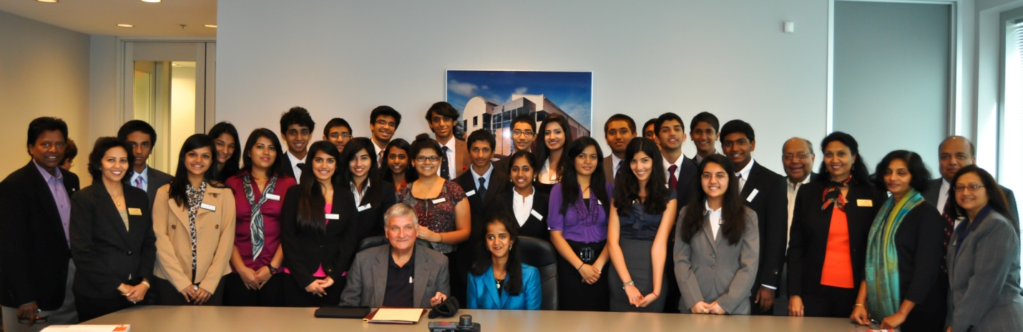

On Saturday November 12, YLDP of Houston held its second classroom session at the Lighthouse. Juniors and seniors from the Indo-American community met to discuss the importance of charity and philanthropy in leadership.

The Lighthouse is a center where the blind and visually impaired are provided vocational training and taught to live as independent and productive lives as they possibly can. Mr. Gibson DuTerroil, president of the Lighthouse, spoke to the YLDP students about the programs and gave a tour of the facility. He reminded the students that “service to others is the rent we pay for our space on earth.” Following the tour, the students listened to Ms. Sandhya Rao, a visually impaired Law Clerk under Judge Rosenthal; speak about overcoming adversity to make the most of each moment of their lives.

Two months after her birth, Ms. Rao developed Hong Kong Flu (similar to the modern day H1N1 flu). Shortly thereafter, she was diagnosed with osteopetrosis – excessive calcium, causing brittle bones - and, in an attempt to widen the ocular canal an accident caused complete blindness in her right eye and only partial vision in her left. However, through perseverance and dedication, she graduated 7th in her class from Sharpstown High. Ms. Rao continued her education in behavioral science and psychology at Rice University followed by Law School at Stanford University. Today, Ms. Rao is the Pro Se Law Clerk for the US District Courts where she reviews the decisions of the state courts. “I am lucky to have what I do have,” she says, “I don’t really want to fix my blindness; I wouldn’t appreciate life as much without it.” Also, Ms. Rao gave the group perspective and insight into what it is like to overcome a “crucible” – a transformative experience through which an individual comes to a new or an altered sense of identity (HBR – Crucibles of Leadership). Even with blindness, she works, has fun, and in general, loves life.

**Reported By Team 4- (Priya B., Sanjiv G., Khushi P., Nicole B., and Srimahesh V.)**